Figure with different color boxes for system and algorithm tests, diagnostics at bottom

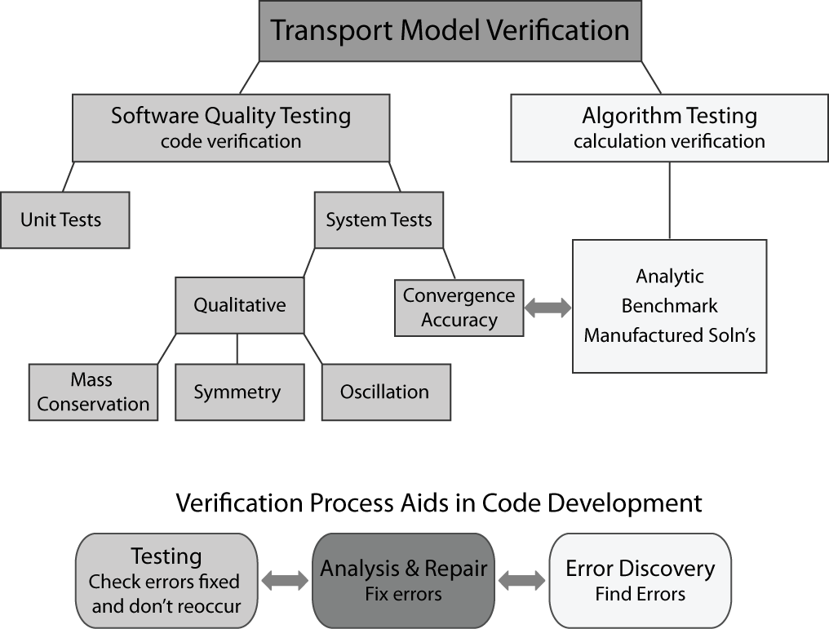

Comment: should we add some text near the double arrow between the convergence/accuracy tests and the algorithm tests????

Figure with all boxes the same color, no diagnostics section at the bottom

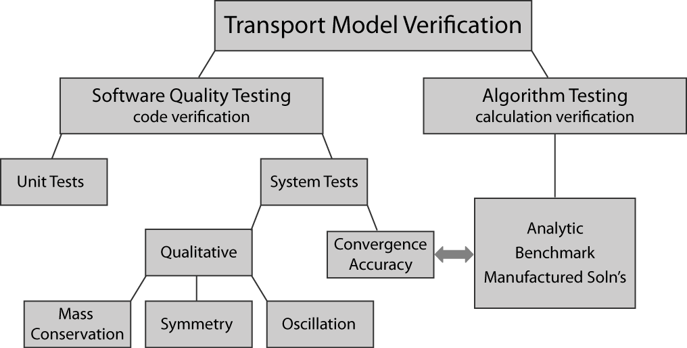

Figure with different color boxes for system tests and algorithm tests, no diagnostics section at the bottom

